<https://www.youtube.com/watch?v=ARfXDSkQf1Y&list=PLblh5JKOoLUK0FLuzwntyYI10UQFUhsY9&index=41>

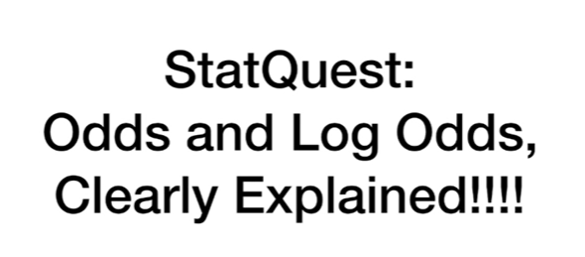

Today we're gonna be talking about odds and log odds and they're gonna be clearly explained.



The odds are in favor that you're already familiar with odds.

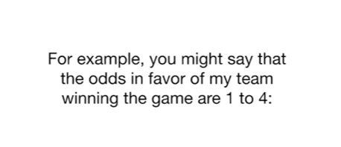

For example, you might say that the odds in favor of my team winning the game are 1 to 4.

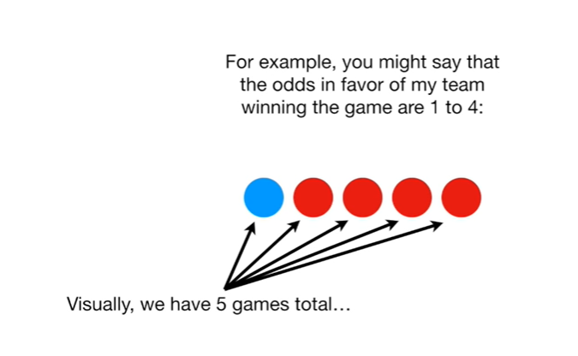

Visually, we have 5 games total

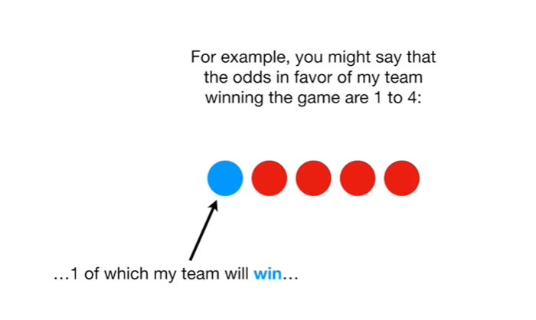

1 of which my team will win

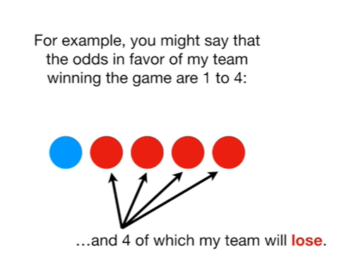

and 4 of which my team will lose.

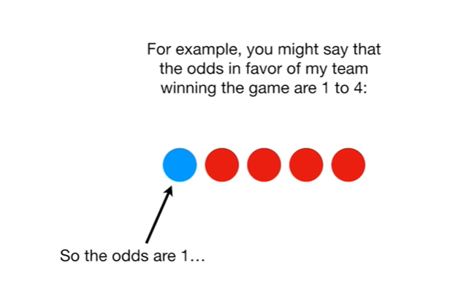

So the odds are 1

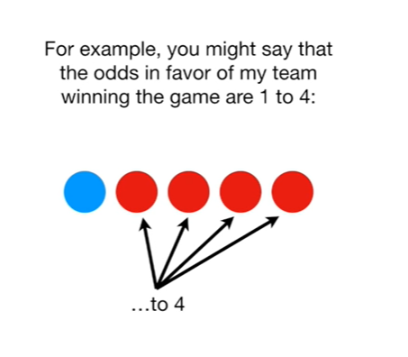

to 4.

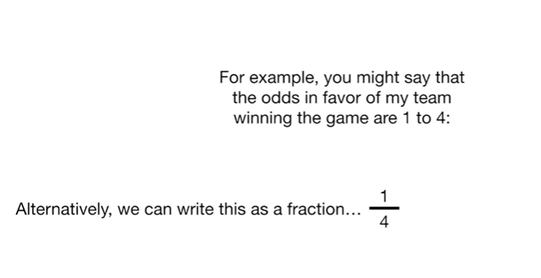

Alternatively, we can write this as a fraction.

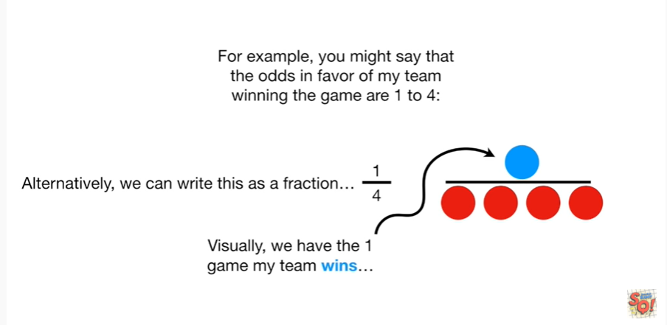

Visually, we have one game my team wins

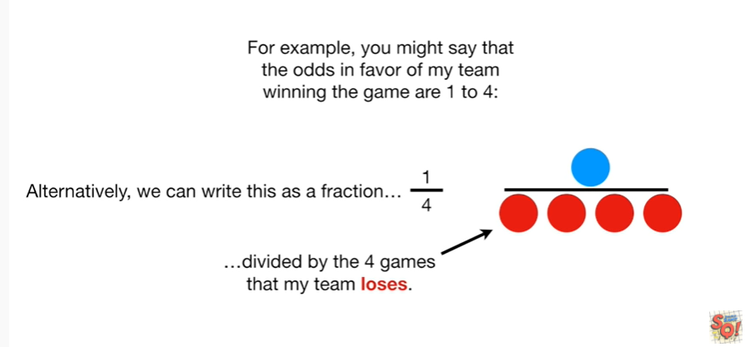

divided by the four games that my team loses.

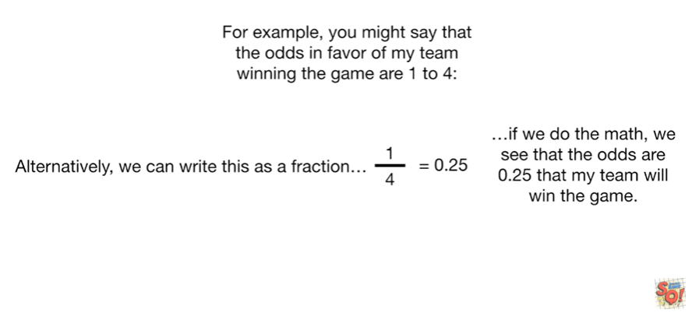

if we do the math, we will see that the odds are 0.25 that my team will win the game.

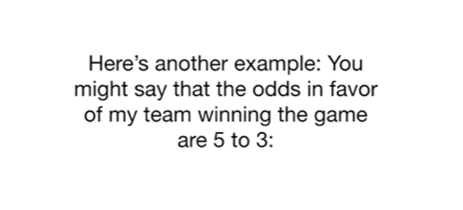

Here's another example : you might say that the odds in favor of my team winning the game are five to three visually :

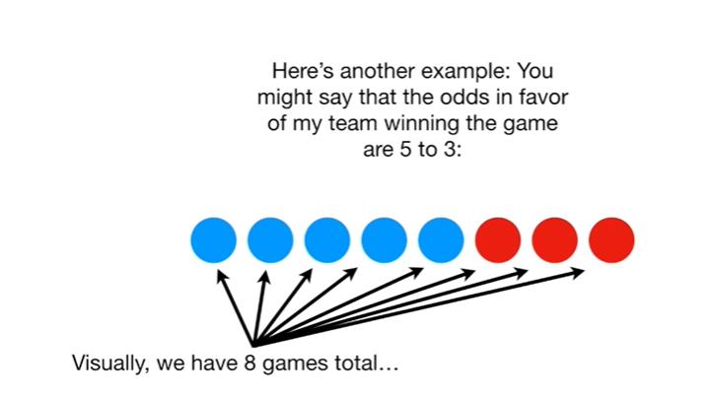

we have eight games total

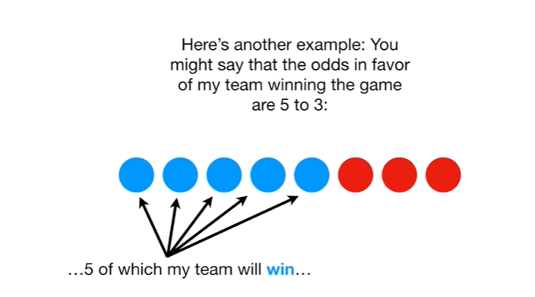

five of which my team will win

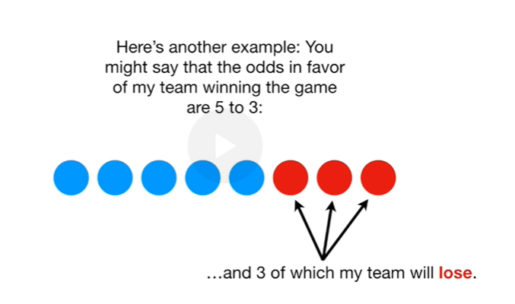

and three of which my team will lose.

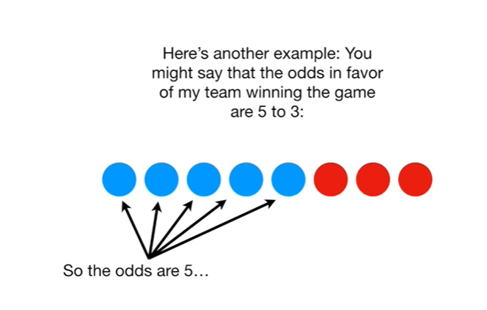

So the odds are five

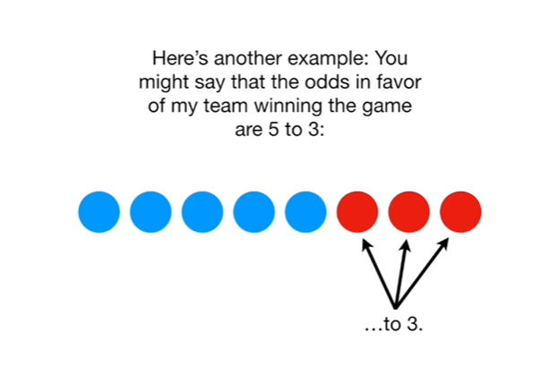

to three.

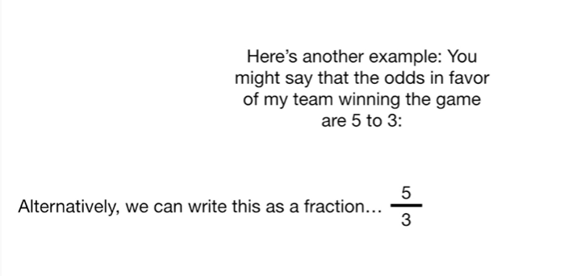

Alternatively, we can write this as a fraction 5/3.

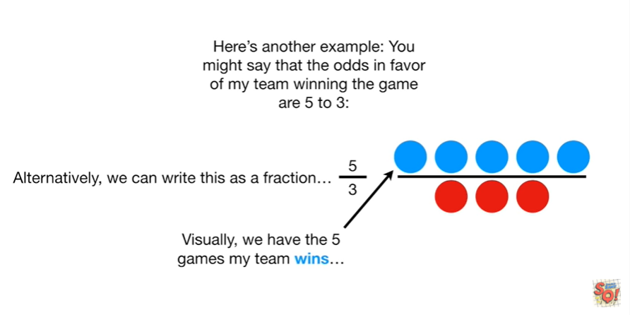

Visually, we have the five games my team wins

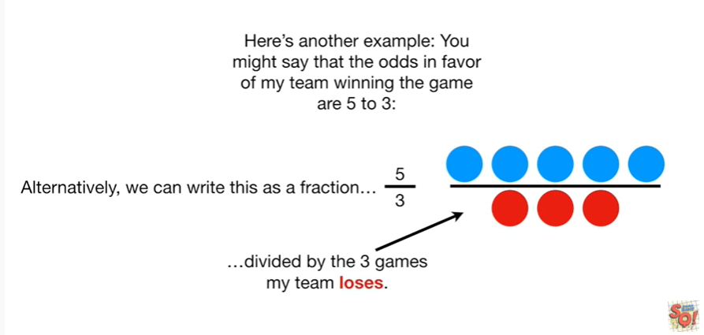

divided by the three games my team loses

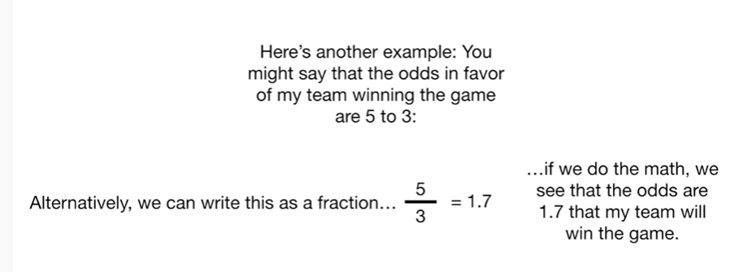

if we do the math, we see that the odds are one point seven that my team will win the game.

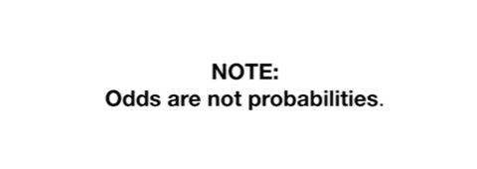

Note : odds are not probabilities.



The odds are the ratio of something happening (ie my team winning)

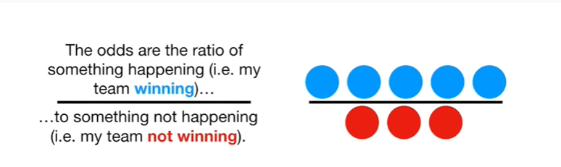

to something not happening (ie my team not winning).

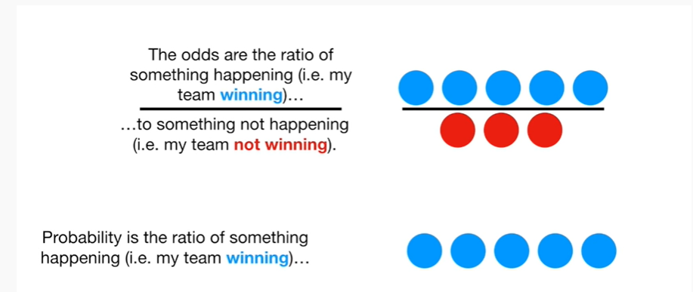

Probability is the ratio of something happening (i.e. my team winning)

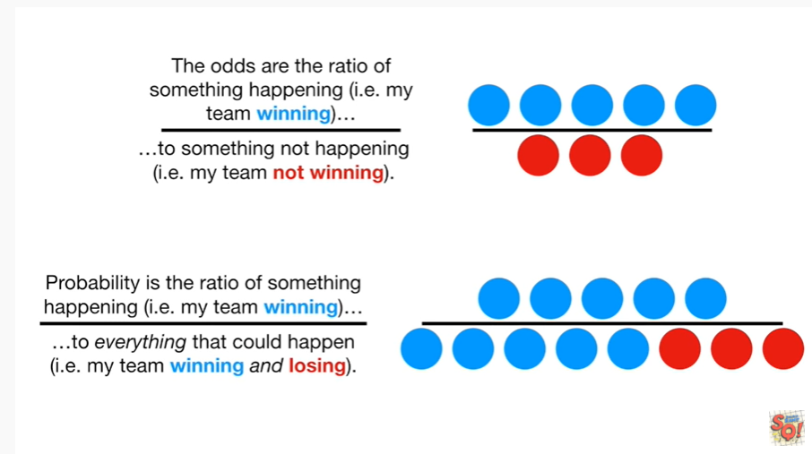

to everything that could happen (ie my team winning and losing).

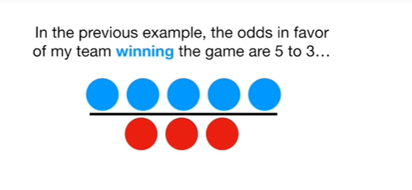

In the previous example, the odds in favor of my team winning the game are five to three

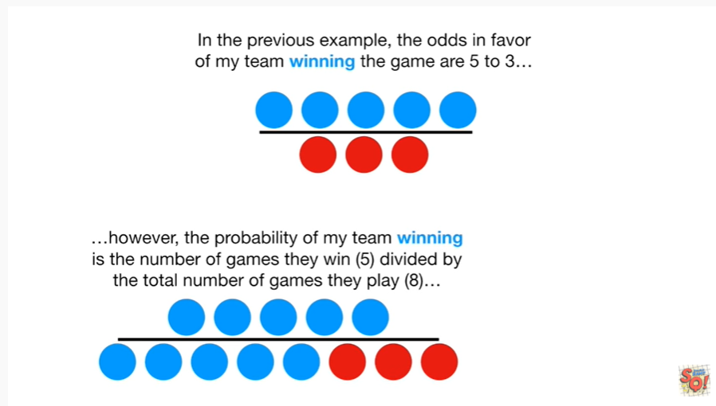

However, the probability of my team winning is the number of games they win (five) divided by the total number of games they play (eight)

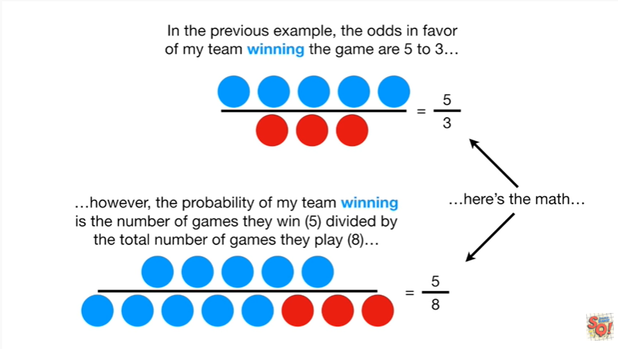

here's the math for the odds we have the ratio of 5 to 3 and for the probability we have the ratio of 5 to 8.

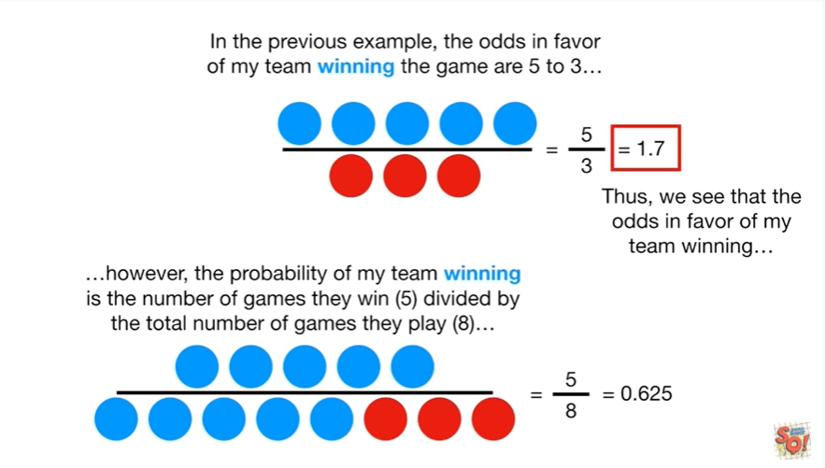

Thus we see that the odds in favor of my team winning

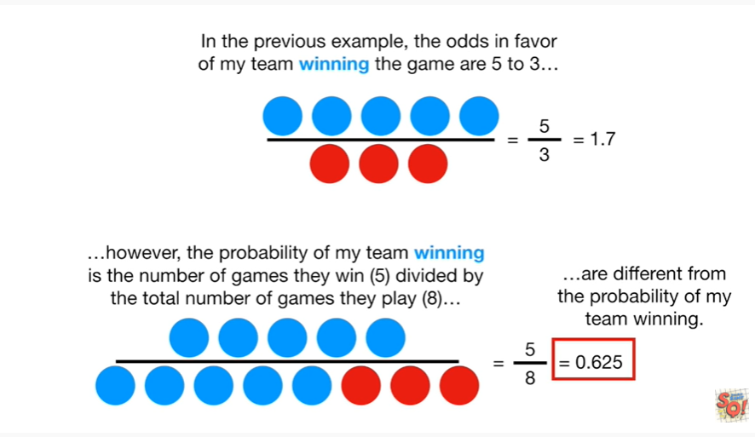

are different from the probability of my team winning.

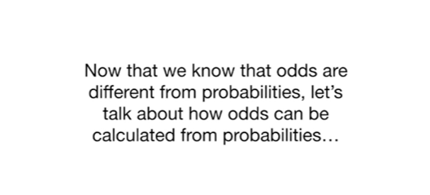

Now that we know that odds are different from probabilities, let's talk about how odds can be calculated from probabilities.



In the last example we saw that the odds of winning are 1 point 7

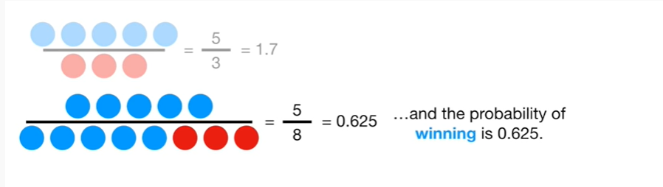

and the probability of winning is 0.625.

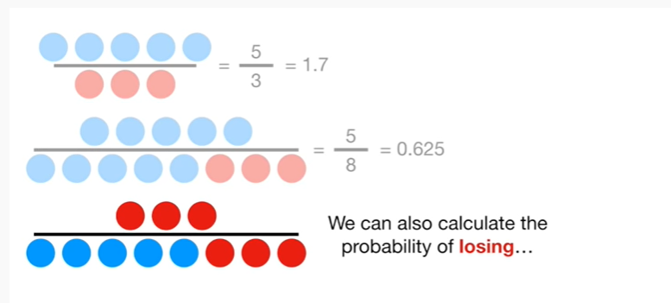

We can also calculate the probability of losing

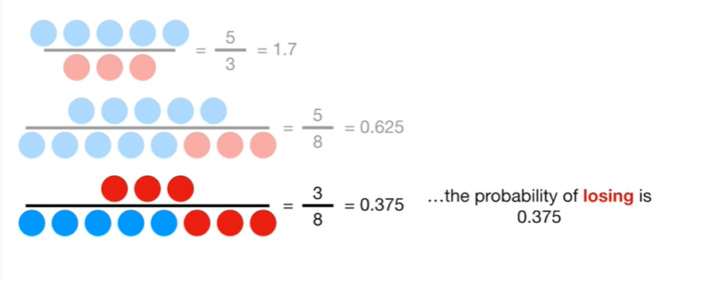

the probability of losing is 0.375.

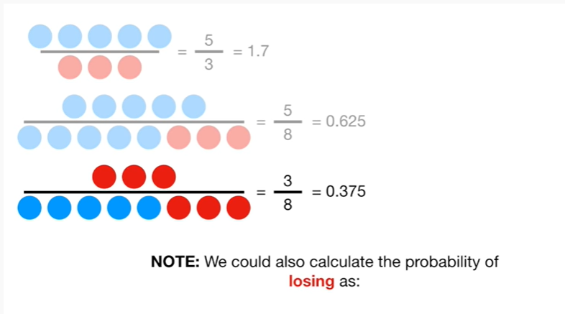

Note : we could also calculate the probability of losing as :

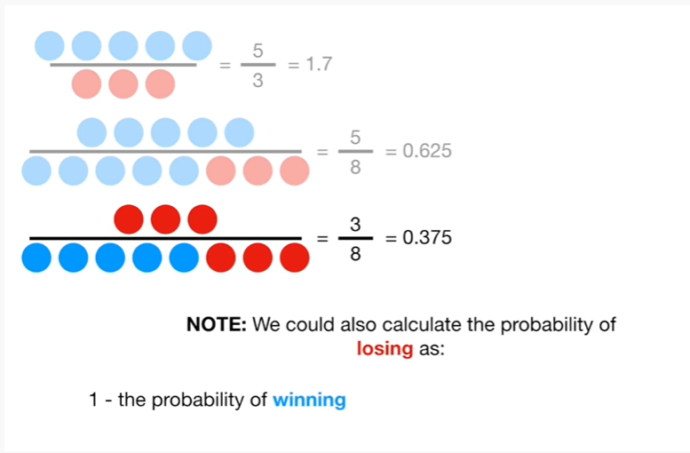

1 minus the probability of winning

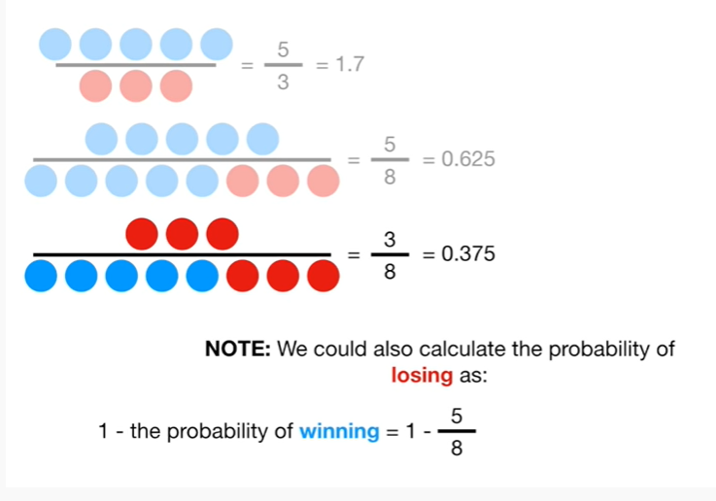

that equals 1 minus 5/8

and that gives us 8 divided by 8 minus 5/8

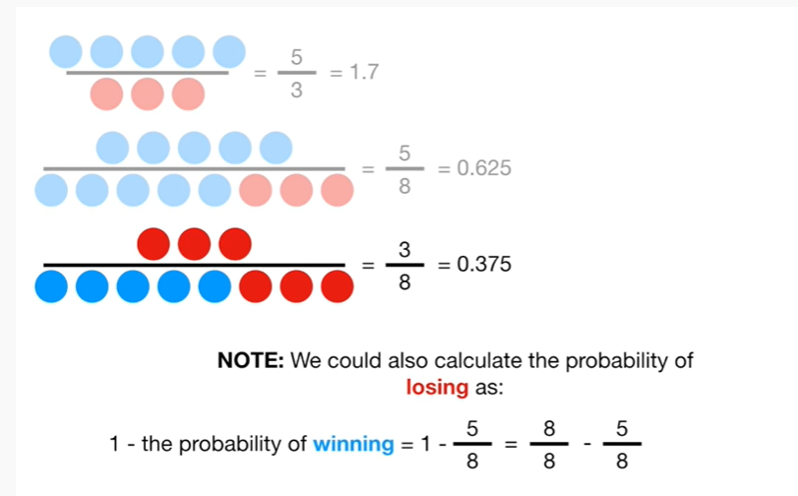

and ultimately we get 3/8.

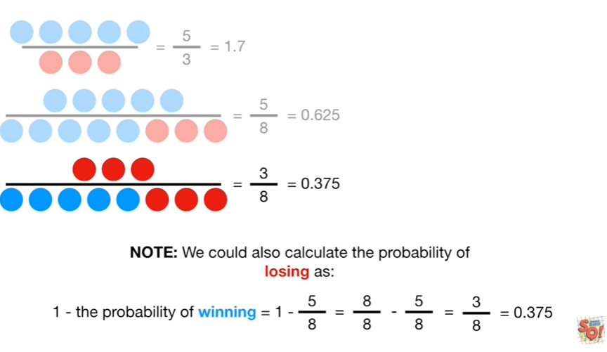

This is equal to 0.375.

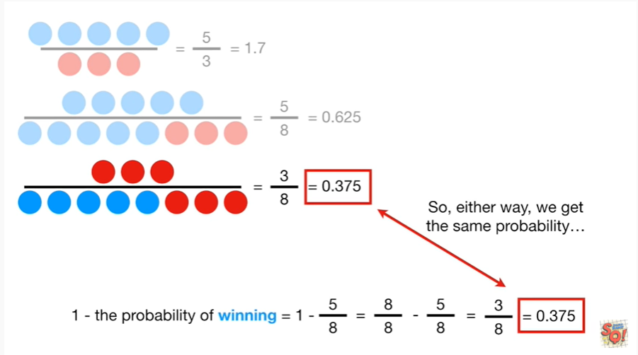

So, either, way we get the same probability.

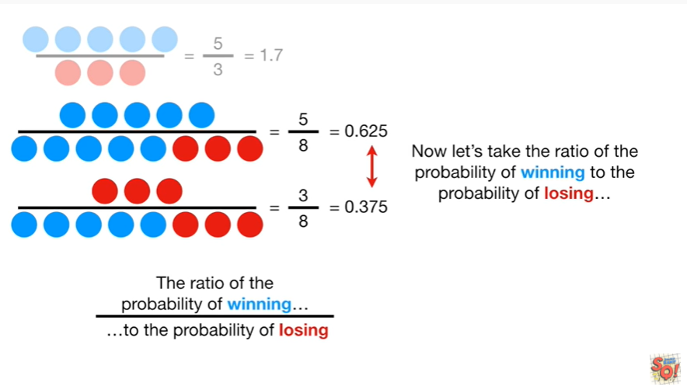

Now let's take the ratio of the probability of winning to the probability of losing.

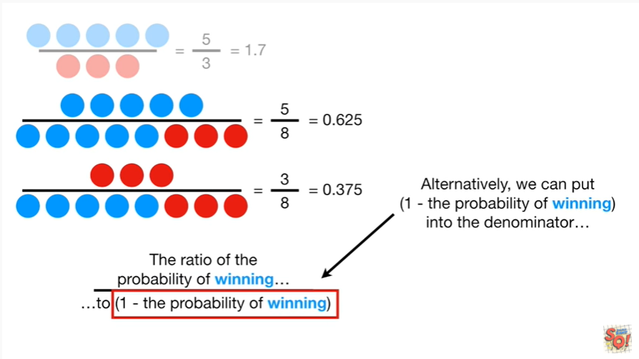

Alternatively we can put (1 minus the probability of winning) into the denominator

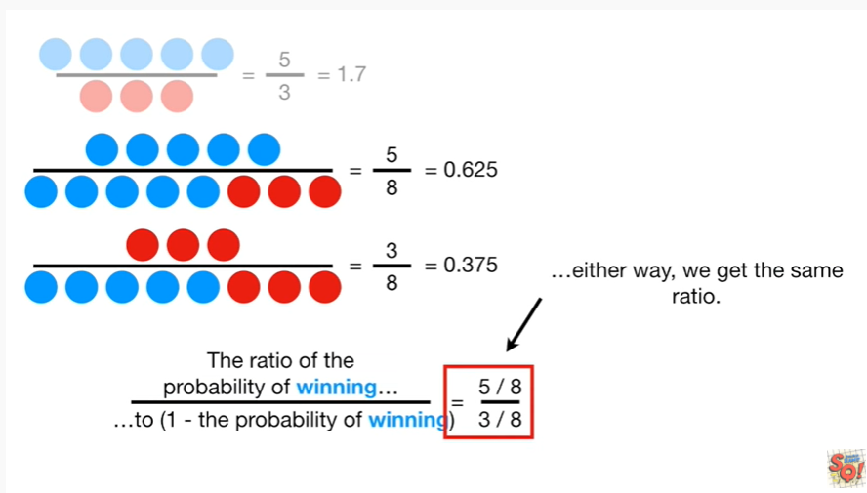

either way, we get the same ratio : 5/8 divided by 3/8.

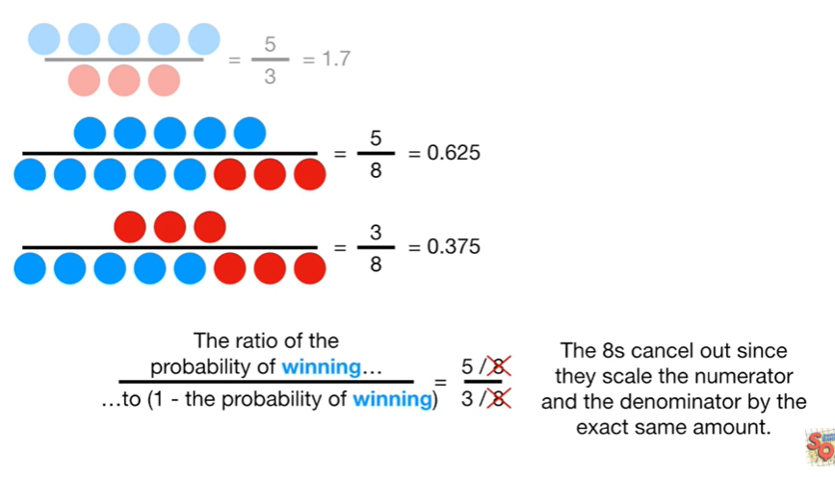

The eights cancel out since they scale the numerator and the denominator by the exact same amount.

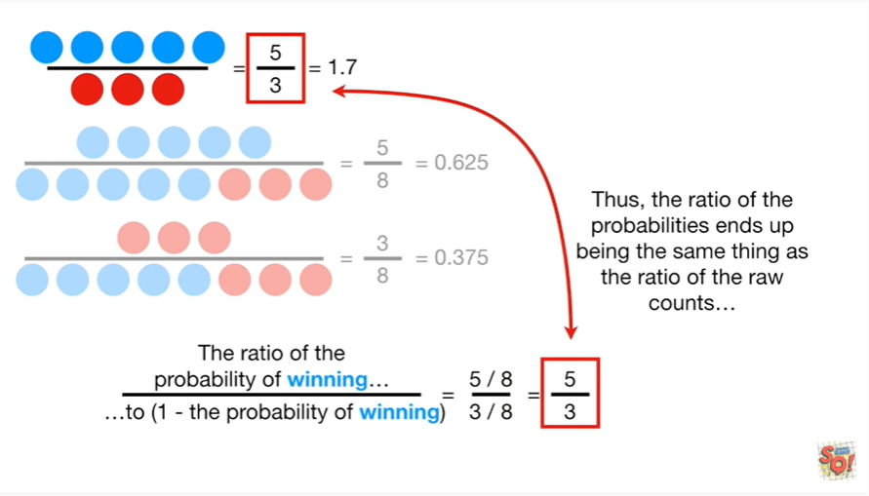

Thus, the ratio of the probability ends up being the same thing as the ratio of the raw counts

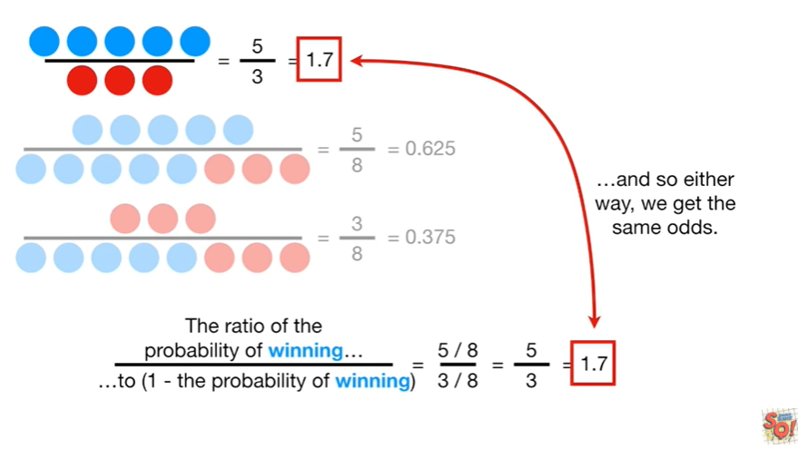

and so either way, we get the same odds 1.7

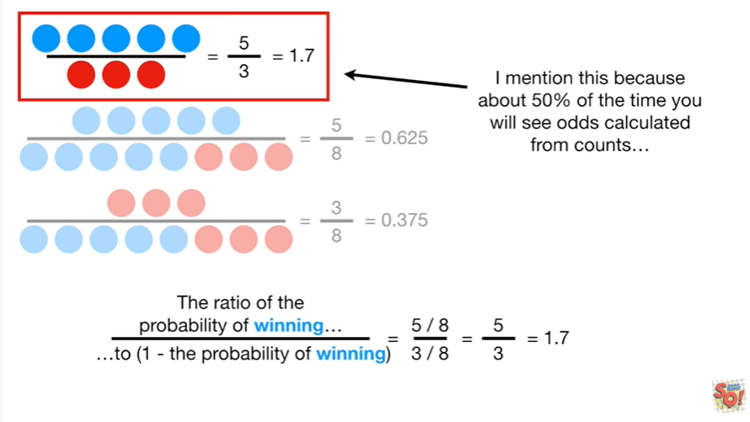

I mentioned this because about 50% of the time you see odds calculated from counts

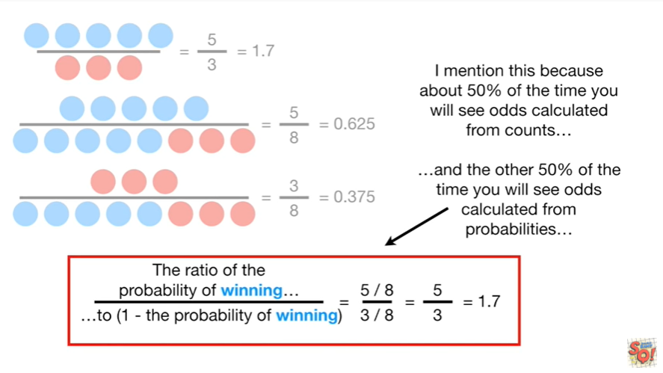

and the other 50% of the time you will see odds calculated from probabilities either way you get the same results.

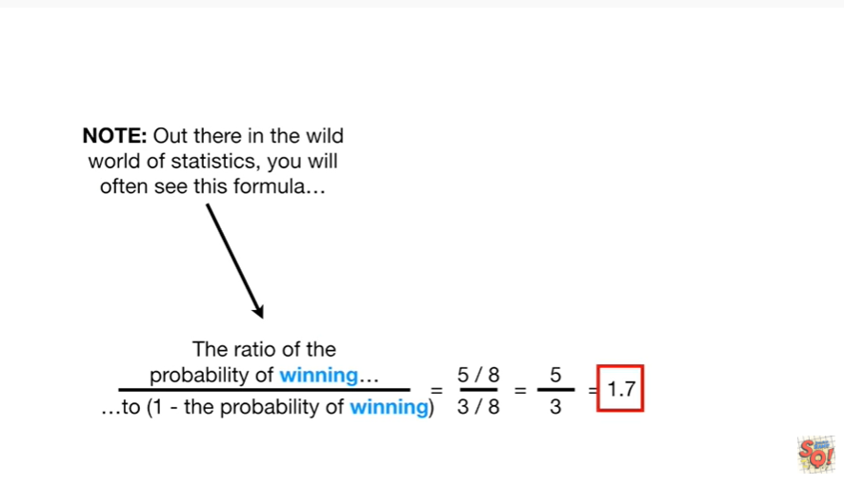

Note : out there in the wild world of statistics, you will often see this formula

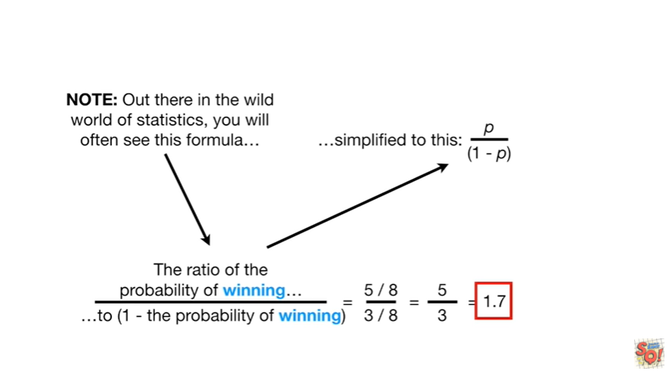

simplified to this

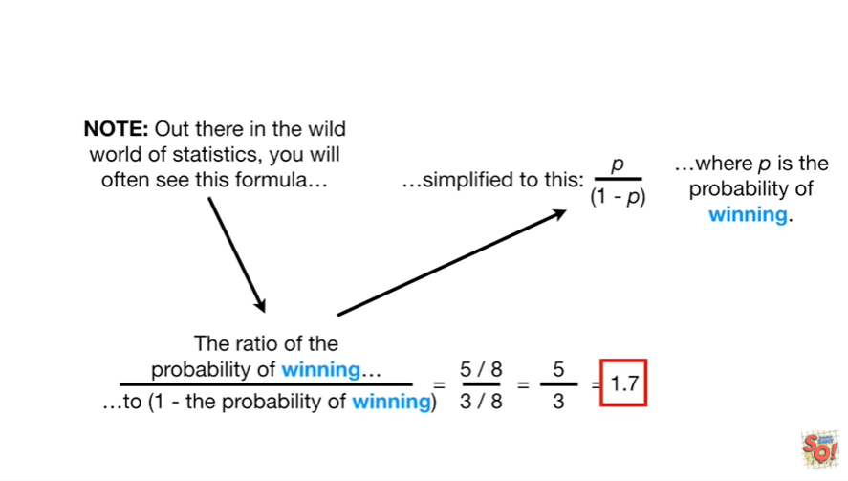

where P is the probability of winning.

BAM !!!

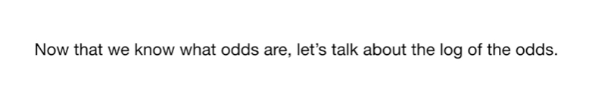

Now that we know what the odds are let's talk about the log of the odds.

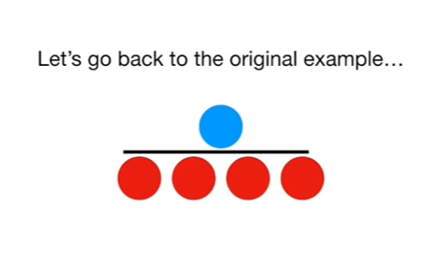

Let's go back to the original example.

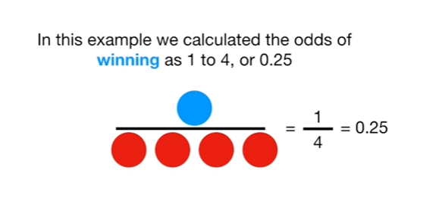

In this example we calculated the odds of winning as one to four or 0.25.

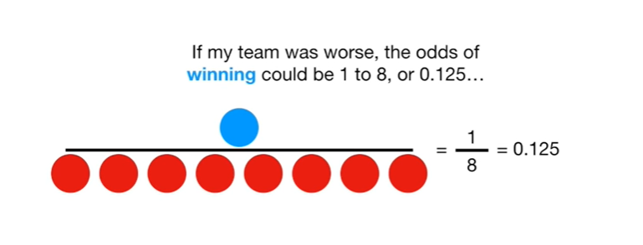

If my team was worse, the odds of winning could be one to eight, or 0.125

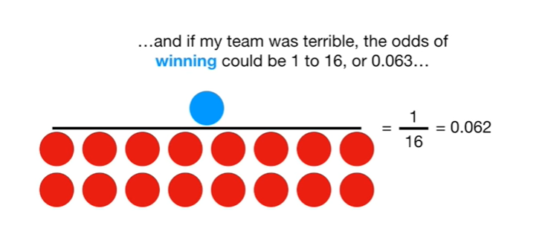

and if my team was terrible, the odds of winning could be one to sixteen or 0.063

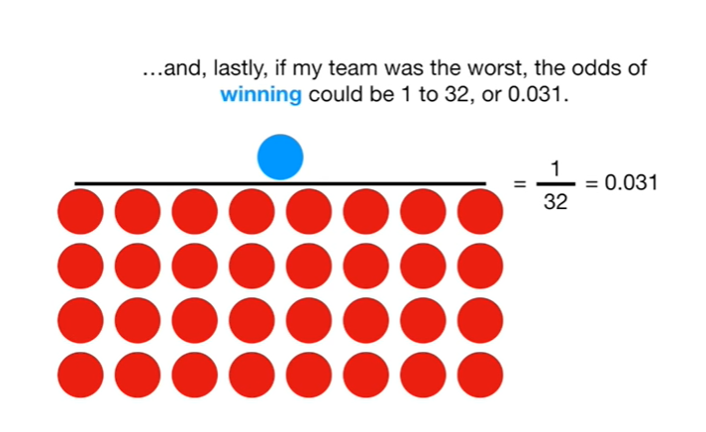

and, lastly, if my team was the worst, the odds of winning could be one to 32 or 0.031.

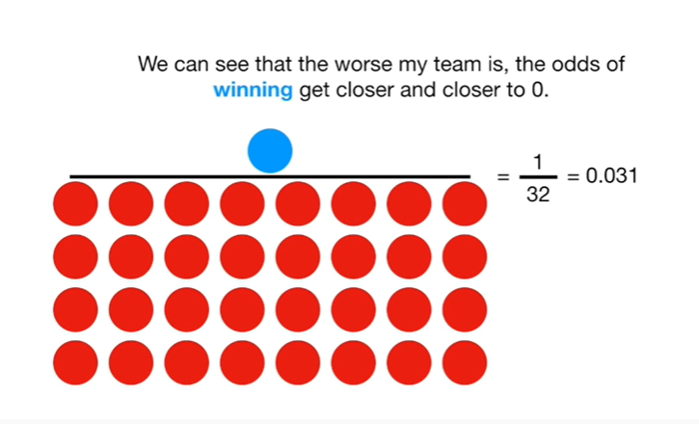

We can see that the worse my team is, the odds of winning get closer and closer to zero.

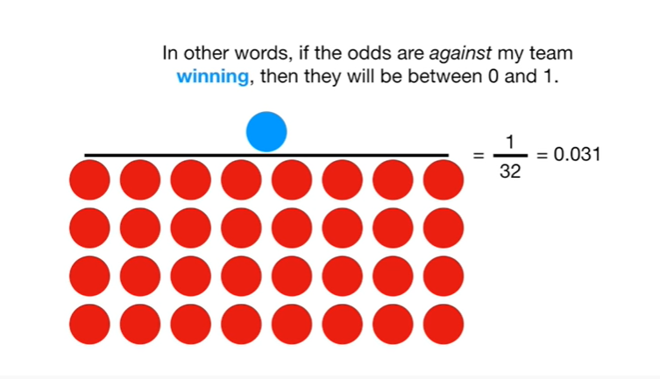

In other words, if the odds are against my team winning, then they will be between zero and one.

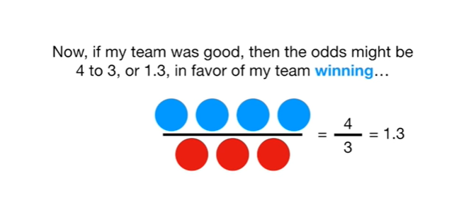

Now, if my team was good, then the odds might be four to three, or one point three, in favor of my team winning

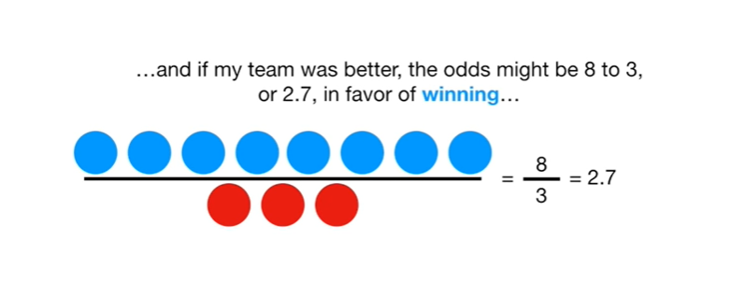

and if my team was better, the odds might be eight to three, or two point seven, in favor of winning

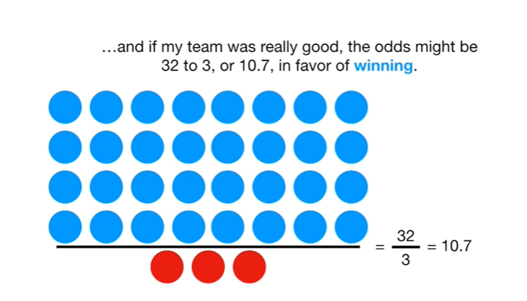

and if my team was really good, the odds might be thirty two to three, or ten point seven, in favor of winning.

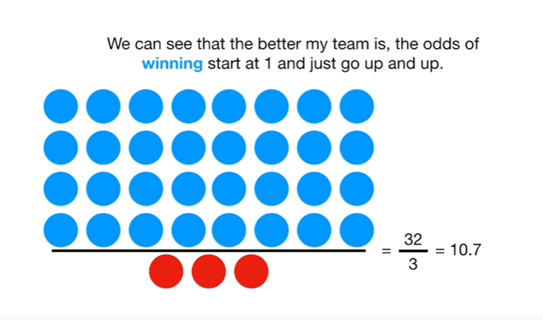

We can see that the better my team is, the odds of winning started one and just go up and up.

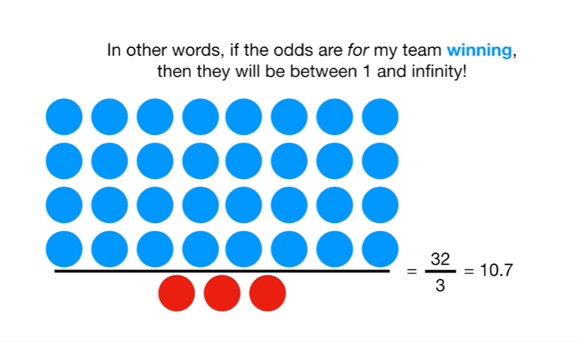

In other words, if the odds are for my team winning, then they will be between 1 and infinity !

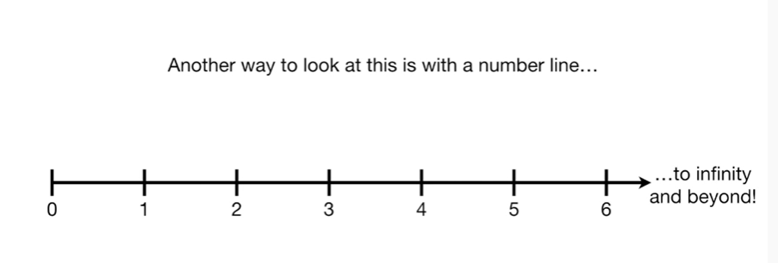

Another way to look at this is with a number line.

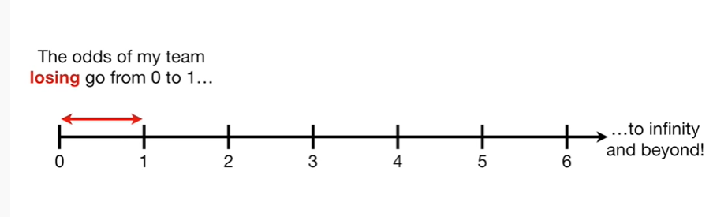

The odds of my team losing go from zero to one

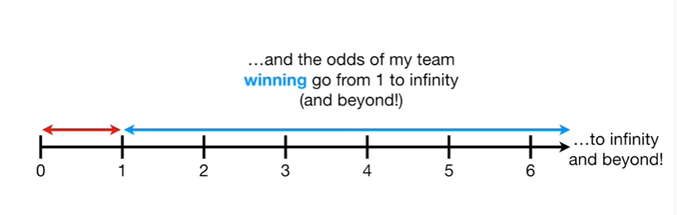

and the odds of my team winning go from one to infinity (and beyond !).

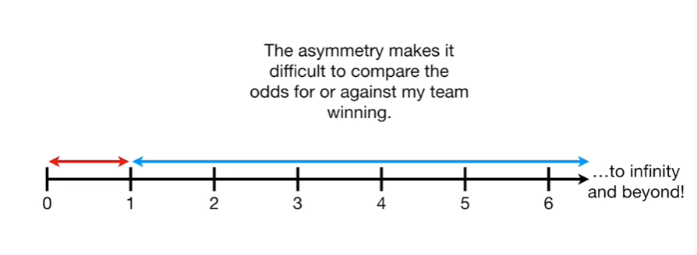

The asymmetry makes it difficult to compare the odds for or against my team winning.

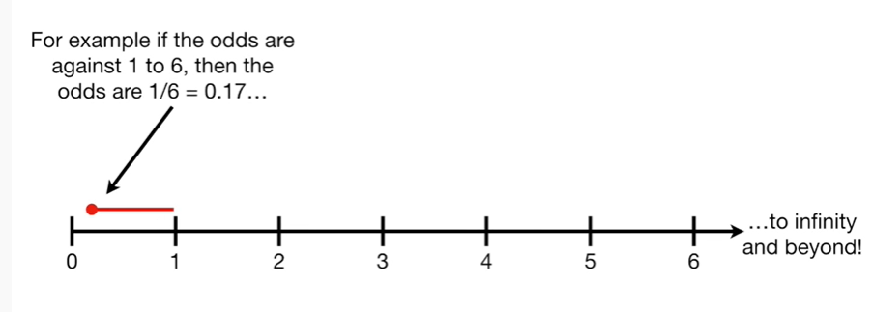

For example if the odds are against one to six, then the odds are 1/6 which equals zero point 1 7

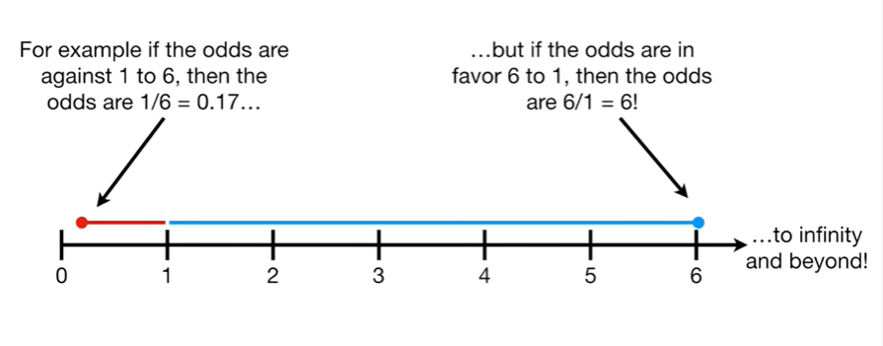

but if the odds are in favor 6 to 1 then the odds are 6 divided by 1 which equals 6 !

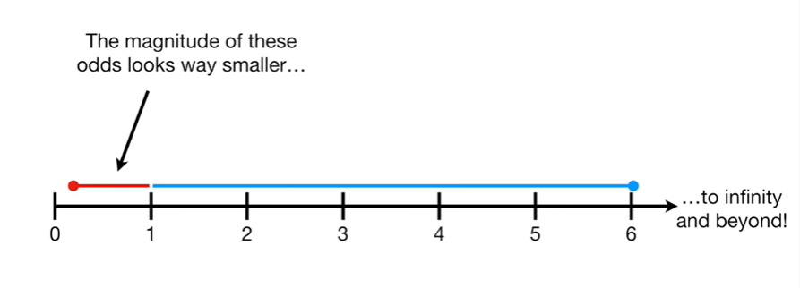

The magnitude of these odds looks way smaller

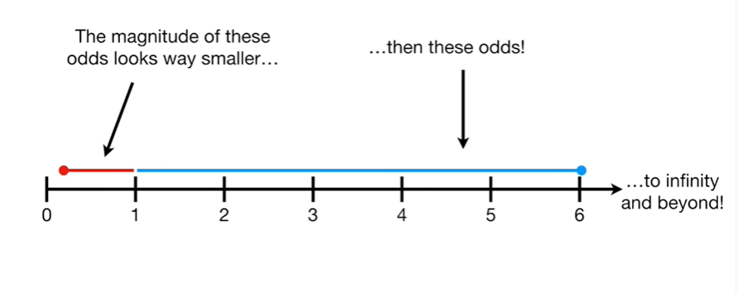

than these odds !

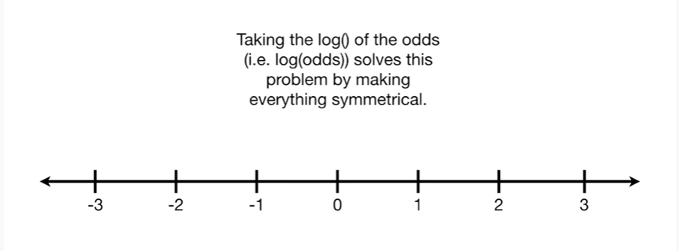

Taking the log() of the odds solves this problem by making everything symmetrical.

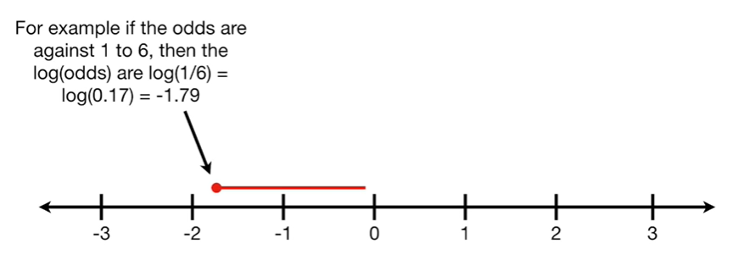

For example if the odds are against one to six, then the log of the odds or the log of one divided by six which equals the log of 0.1 seven which equals negative one point seven nine.

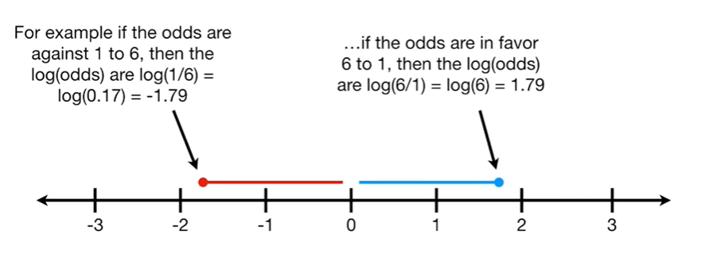

And if the odds are in favor six to one then the log of the odds are the log of 6 divided by 1 which equals the log of 6 which equals one point seven nine.

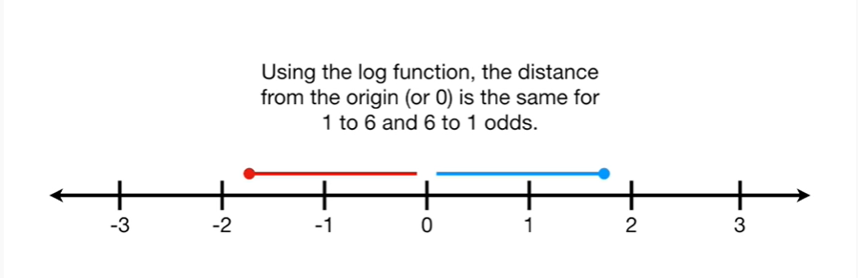

Using the log function, the distance from the origin (or zero) is the same for one to six or six to one odds.

Double bam !!!



Okay, now that we know the main idea about the log of the odds, let's get into some details.

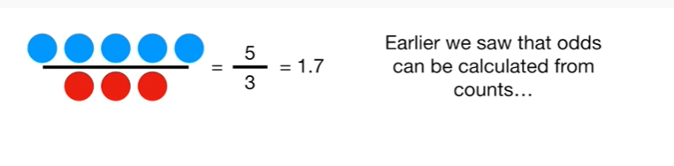

Earlier we saw that odds can be calculated from counts

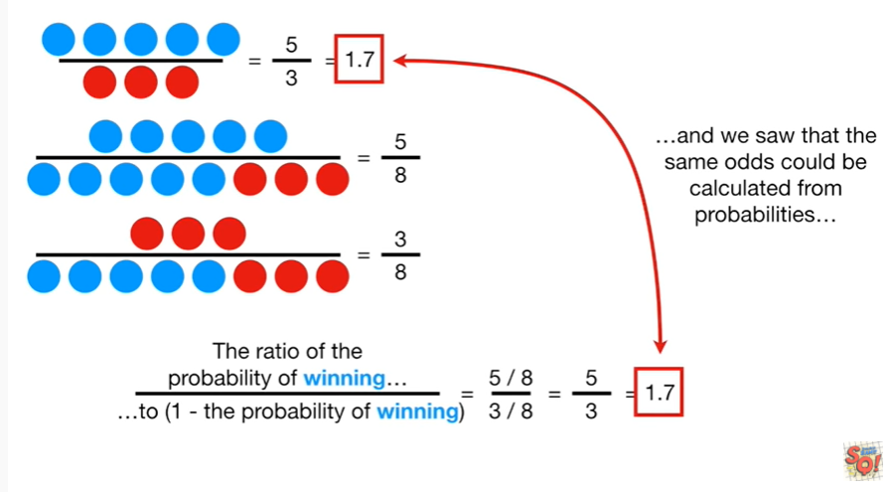

and we saw that the same odds could be calculated from probabilities

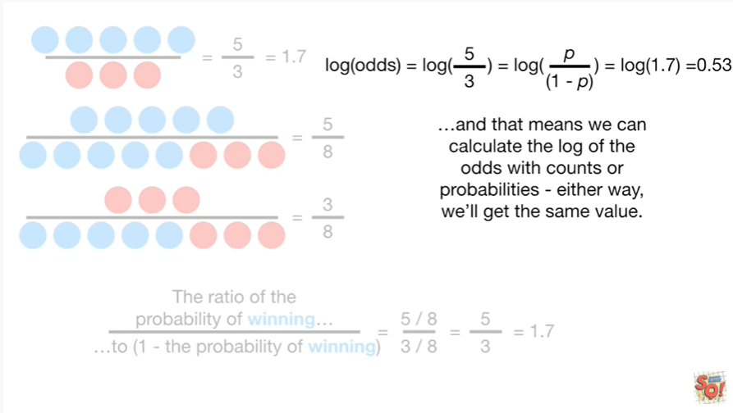

and that means we can calculate the log of the odds with counts or probabilities either way we'll get the same value.

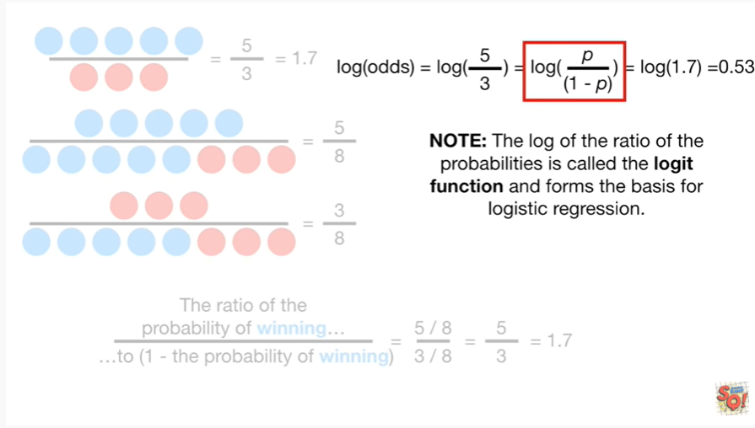

Note : the log of the ratio of the probabilities is called the logit function and it forms the basis for logistic regression.

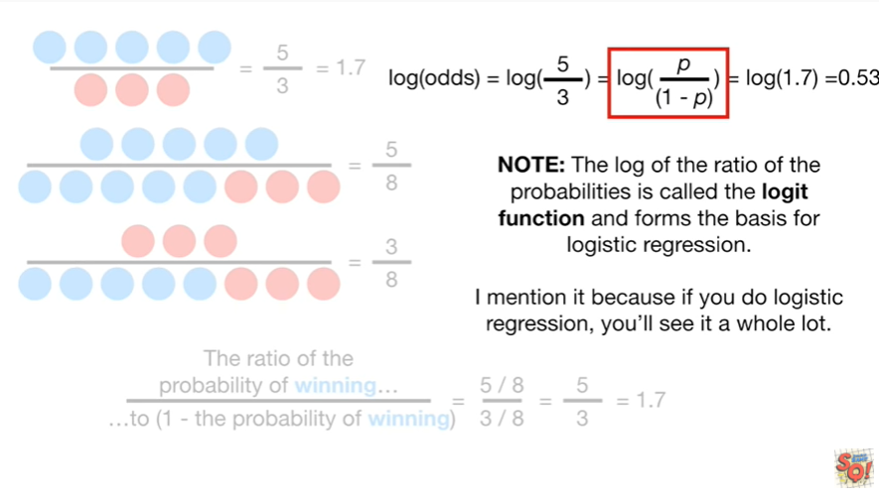

I mention it because if you do logistic regression, you'll see it a whole lot.

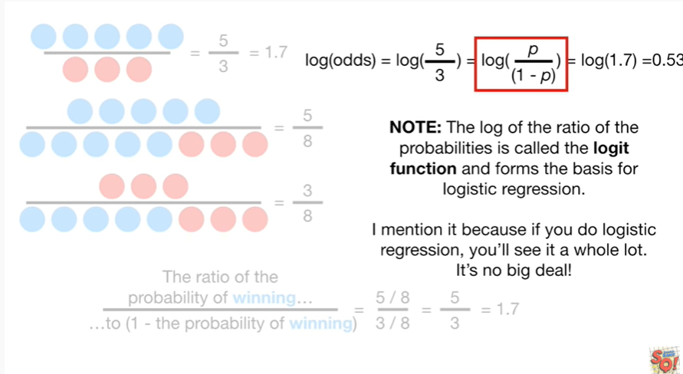

It's no big deal !

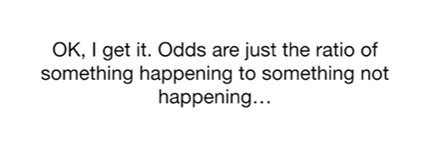

Ok, I get it.

Odds are just the ratio of something happening to something not happening

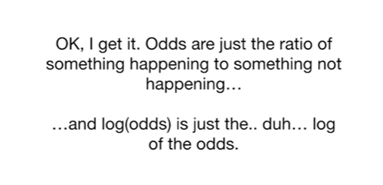

and the log of the odds is just the … duh … log of the odds.

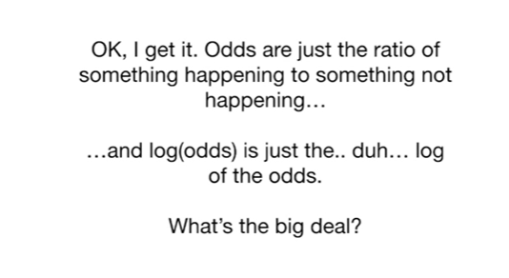

What's the big deal ?

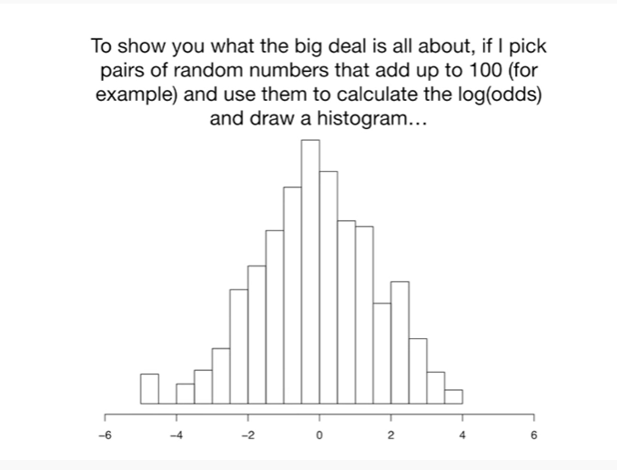

To show you what the big deal is all about, if I pick pairs of random numbers that add up to 100 (for example) and use them to calculate the log of the odds and draw a histogram

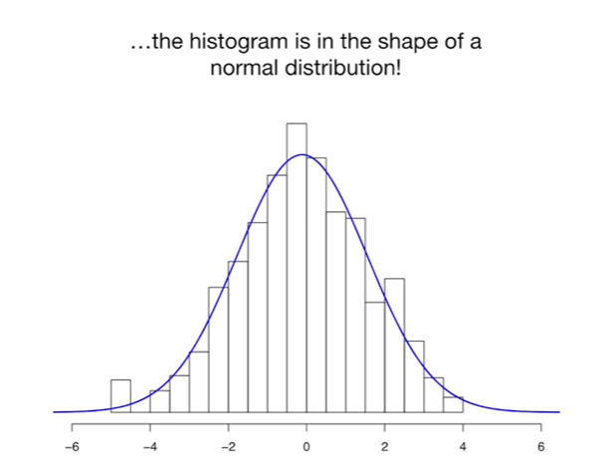

the histogram is in the shape of a normal distribution !

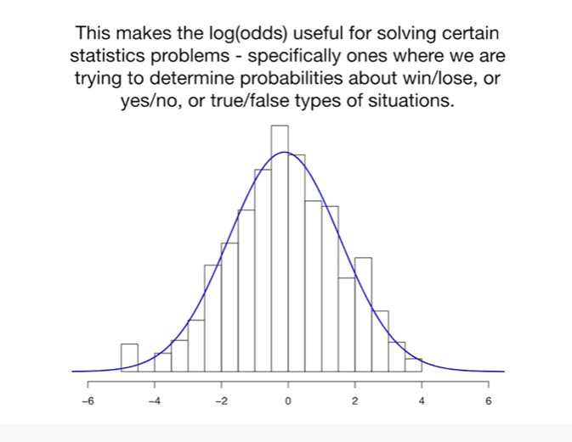

This makes the log of the odds useful for solving certain statistics problems specifically ones where we are trying to determine probabilities about win or lose or yes or no or true or false type situations.

Triple bam !!!



In summary, the odds are just

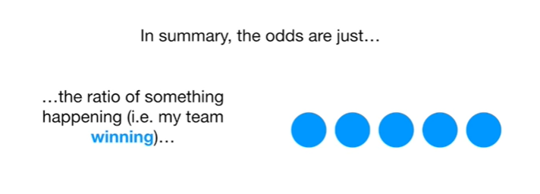

the ratio of something happening (i.e. my team winning)

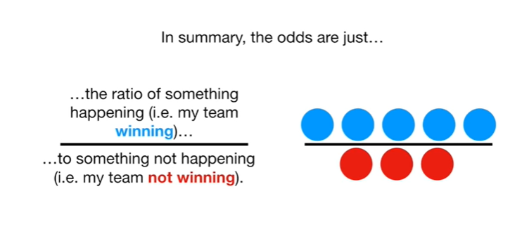

to something not happening (ie my team not winning).

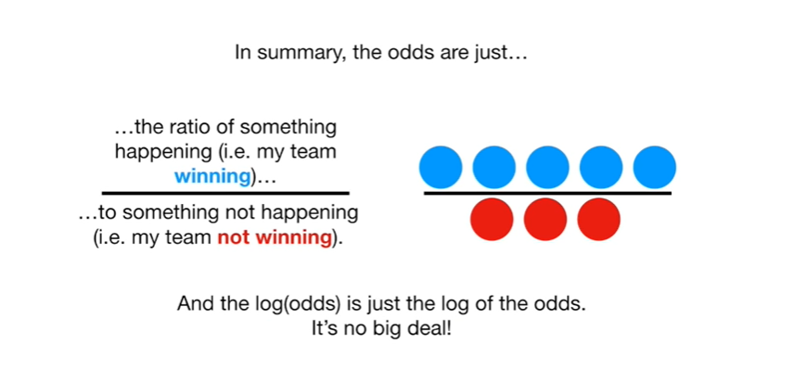

And the log of the odds is just the log of the odds.

It's no big deal !

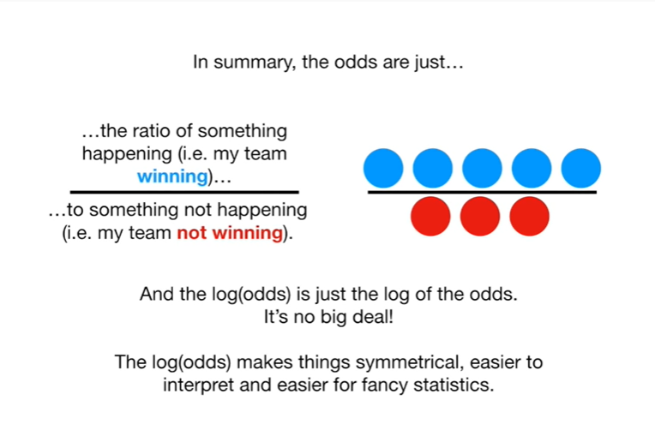

The log of the odds makes things symmetrical, easier to interpret and easier for fancy statistics.



One last thing before we go.

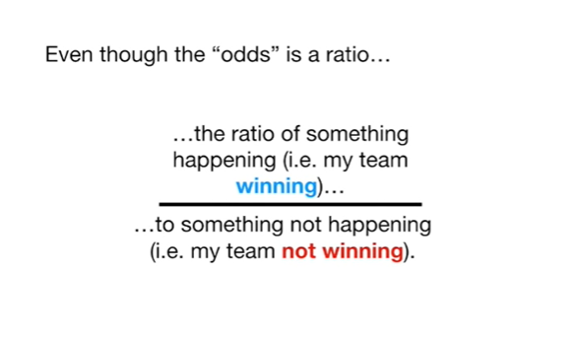

Even though the odds is a ratio

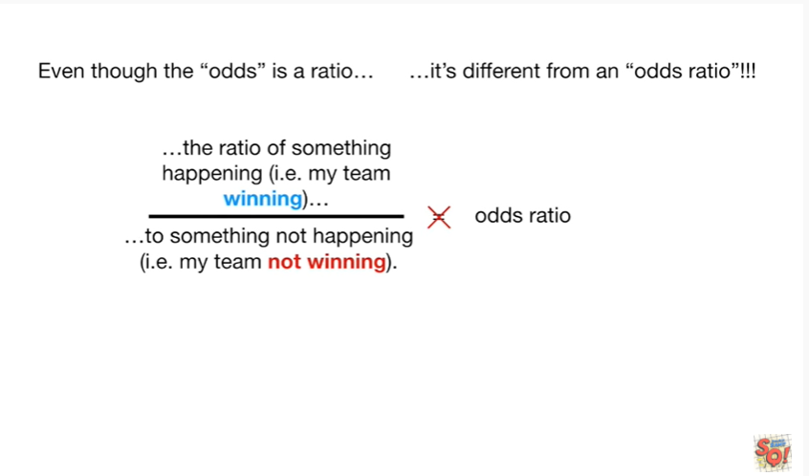

it's different from an odds ratio !!!

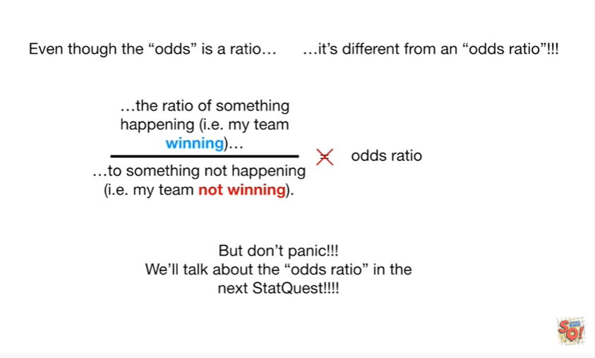

But don't panic !!!

We'll talk about the odds ratio in the next stat quest.